**National Research University**

**«Higher School of Economics»**

Faculty of **«Business and Management»**

School of «**Business Informatics**»

Department of

**Information Systems and Digital Infrastructure Management**

***Team project on the course   
«Programming»***

Completed by: students group 145

Khorin M.

Khorin R.

Vlasovets O.

phone. ___________________

e-mail: ___________________

Manager: Efremov S. G.

Moscow

2016

|  |
| --- |
| **Table of Contents** |
| 1. Topic of the project / program name 2. Annotation 3. Central repository address 4. Members of the team and their roles 5. Application structure   5.1. Class diagram  5.2. Classes description   1. Program interface |

1. **Topic of the project / program name.**

The main topic of the project is creating an application that allows scheduling and managing plans with the ability to save plans list. Program name: Team_Project.sln.

1. **Annotation.**

The program is a graphical user interface, which contains several windows that provide their own functionality such as authorization and registration of the user, adding, editing, deleting, completing and saving user’s plans. The information about plans and users is stored in a database. The database has two entities: Plan and User. Plan entity has such attributes as Id, User_login (FK), Description, IsCompleted, Deadline, Date. User entity has such attributes as Login, Password, Name, Surname, Date_of_birth. The user must be registered in the program to manage and manipulate his plans.

1. **Central repository address.**

Central repository address is a GitHub repository. URL: <https://github.com/RomanKhorin/organiser_proj/>

1. **Members of the team and their roles.**

Khorin Maxim – responsible for graphical user interface, style and design;

Khorin Roman – responsible for application logic;

Vlasotets Oleg – responsible for database architecture and management;

# **Application structure.**

* 1. **Class diagram.**

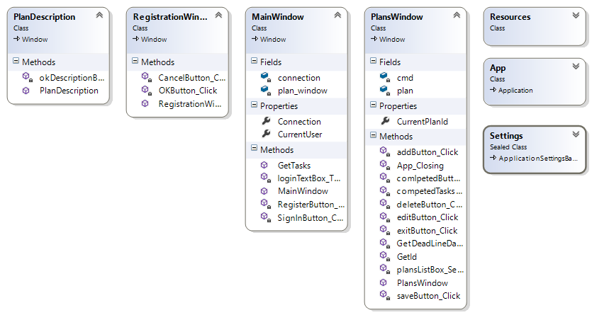

**5.2 Classes description.**

# Team_Project - namespace

## Classes

|  |  |  |
| --- | --- | --- |
|  | Class | Description |
| Открытый класс | App | Interaction logic for App.xaml |
| Открытый класс | MainWindow | Interaction logic for MainWindow.xaml |
| Открытый класс | PlanDescription | Interaction logic for PlanDescription.xaml |
| Открытый класс | PlansWindow | Interaction logic for LoginWindow.xaml |
| Открытый класс | RegistrationWindow | Interaction logic for RegistrationWindow.xaml |

# MainWindow - Class

Interaction logic for MainWindow.xamlMainWindow

## Inheritance

[System.Object](http://msdn2.microsoft.com/ru-ru/library/e5kfa45b)  
  [System.Windows.Threading.DispatcherObject](http://msdn2.microsoft.com/ru-ru/library/ms615925)  
    [System.Windows.DependencyObject](http://msdn2.microsoft.com/ru-ru/library/ms589309)  
      [System.Windows.Media.Visual](http://msdn2.microsoft.com/ru-ru/library/ms635637)  
        [System.Windows.UIElement](http://msdn2.microsoft.com/ru-ru/library/ms590078)  
          [System.Windows.FrameworkElement](http://msdn2.microsoft.com/ru-ru/library/ms602714)  
            [System.Windows.Controls.Control](http://msdn2.microsoft.com/ru-ru/library/ms609826)  
              [System.Windows.Controls.ContentControl](http://msdn2.microsoft.com/ru-ru/library/ms609797)  
                [System.Windows.Window](http://msdn2.microsoft.com/ru-ru/library/ms590112)  
                  Team_Project.MainWindow

**Namespace:** Team_Project  
**Build:** Team_Project (in Team_Project.exe) Version: 1.0.0.0 (1.0.0.0)

## Syntax

|  |
| --- |
| C# |
| public class MainWindow : Window, IComponentConnector |

## Constructors

|  |  |  |
| --- | --- | --- |
|  | Name | Description |
| Открытый метод | MainWindow |  |

## Methods

|  |  |  |
| --- | --- | --- |
|  | Name | Description |
| Открытый метод | GetTasks | Queries the DataBase, gets the uncompleted user's tasks and adds them to the plans listbox |
| Защищённый метод | InitializeComponent | InitializeComponent |
| Открытый метод | loginTextBox_TextChanged | Gets the current user name from the login textbox |
| Открытый метод | RegisterButton_Click | Opens the registration window so user could sign up |
| Защищённый метод | SignInButton_Click | After pressing the "Sign In" button checks if the user's login and password exist in DataBase and after that may open the new plans window |

## Fields

|  |  |  |
| --- | --- | --- |
|  | Name | Description |
| Закрытое поле | connection |  |
| Закрытое поле | plan_window | Instance of the PlanWindow class |

## Properties

|  |  |  |
| --- | --- | --- |
|  | Name | Description |
| Открытое свойствоСтатический член | Connection | Current connection string to SQL DataBase |
| Открытое свойствоСтатический член | CurrentUser | Current User in application |

# PlanDescription - Class

Interaction logic for PlanDescription.xamlPlanDescription

## Inheritance

[System.Object](http://msdn2.microsoft.com/ru-ru/library/e5kfa45b)  
  [System.Windows.Threading.DispatcherObject](http://msdn2.microsoft.com/ru-ru/library/ms615925)  
    [System.Windows.DependencyObject](http://msdn2.microsoft.com/ru-ru/library/ms589309)  
      [System.Windows.Media.Visual](http://msdn2.microsoft.com/ru-ru/library/ms635637)  
        [System.Windows.UIElement](http://msdn2.microsoft.com/ru-ru/library/ms590078)  
          [System.Windows.FrameworkElement](http://msdn2.microsoft.com/ru-ru/library/ms602714)  
            [System.Windows.Controls.Control](http://msdn2.microsoft.com/ru-ru/library/ms609826)  
              [System.Windows.Controls.ContentControl](http://msdn2.microsoft.com/ru-ru/library/ms609797)  
                [System.Windows.Window](http://msdn2.microsoft.com/ru-ru/library/ms590112)  
                  Team_Project.PlanDescription

**Namespace:** Team_Project  
**Build:** Team_Project (in Team_Project.exe) Version: 1.0.0.0 (1.0.0.0)

## Syntax

|  |
| --- |
| C# |
| public class PlanDescription : Window,   IComponentConnector |

## Constructors

|  |  |  |
| --- | --- | --- |
|  | Name | Description |
| Открытый метод | PlanDescription |  |

## Methods

|  |  |  |
| --- | --- | --- |
|  | Name | Description |
| Закрытый метод | okDescriptionButton_Click | Closes the PlansDescription Window |

# PlansWindow - Class

Interaction logic for LoginWindow.xamlPlansWindow

## Inheritance

[System.Object](http://msdn2.microsoft.com/ru-ru/library/e5kfa45b)  
  [System.Windows.Threading.DispatcherObject](http://msdn2.microsoft.com/ru-ru/library/ms615925)  
    [System.Windows.DependencyObject](http://msdn2.microsoft.com/ru-ru/library/ms589309)  
      [System.Windows.Media.Visual](http://msdn2.microsoft.com/ru-ru/library/ms635637)  
        [System.Windows.UIElement](http://msdn2.microsoft.com/ru-ru/library/ms590078)  
          [System.Windows.FrameworkElement](http://msdn2.microsoft.com/ru-ru/library/ms602714)  
            [System.Windows.Controls.Control](http://msdn2.microsoft.com/ru-ru/library/ms609826)  
              [System.Windows.Controls.ContentControl](http://msdn2.microsoft.com/ru-ru/library/ms609797)  
                [System.Windows.Window](http://msdn2.microsoft.com/ru-ru/library/ms590112)  
                  Team_Project.PlansWindow

**Namespace:** Team_Project  
**Build:** Team_Project (in Team_Project.exe) Version: 1.0.0.0 (1.0.0.0)

## Syntax

|  |
| --- |
| C# |
| public class PlansWindow : Window,   IComponentConnector |

## Constructors

|  |  |  |
| --- | --- | --- |
|  | Name | Description |
| Открытый метод | PlansWindow |  |

## Methods

|  |  |  |
| --- | --- | --- |
|  | Name | Description |
| Закрытый метод | addButton_Click | Adds the plan to the DataBase and plans listbox after filling the plan description in PlanDescription Window |
| Закрытый метод | App_Closing | Closing event handler |
| Закрытый метод | comlpetedButton_Click | Marks the selected task as completed after pressing the "Completed" button |
| Закрытый метод | competedTasksButton_Click | Shows completed tasks after pressing the "Show completed tasks" button |
| Закрытый метод | deleteButton_Click | Deletes selected plan from the DataBase and plans listbox |
| Закрытый метод | editButton_Click | Allows the user to edit the selected plan after pressing the "Edit" button, |
| Закрытый метод | exitButton_Click | Shuts down the application after pressing the "Exit" button |
| Закрытый метод | GetDeadLineDate | Gets the deadline date for selected plan in plans listbox |
| Закрытый метод | GetId | Gets the Id for the selected plan in plans listbox |
| Закрытый метод | plansListBox_SelectionChanged | Sets the Id for the selected plan in plans listbox |
| Закрытый метод | saveButton_Click | Saves uncompleted plans to the text file after pressing the "Save" button |

## Fields

|  |  |  |
| --- | --- | --- |
|  | Name | Description |
| Закрытое поле | cmd | Instance of the SqlCommand class |
| Закрытое поле | plan | Instance of the PlnaDescription class |

## Properties

|  |  |  |
| --- | --- | --- |
|  | Name | Description |
| Открытое свойствоСтатический член | CurrentPlanId | Current Id for selected plan in plans listbox |

# RegistrationWindow - Class

Interaction logic for RegistrationWindow.xamlRegistrationWindow

## Inheritance

[System.Object](http://msdn2.microsoft.com/ru-ru/library/e5kfa45b)  
  [System.Windows.Threading.DispatcherObject](http://msdn2.microsoft.com/ru-ru/library/ms615925)  
    [System.Windows.DependencyObject](http://msdn2.microsoft.com/ru-ru/library/ms589309)  
      [System.Windows.Media.Visual](http://msdn2.microsoft.com/ru-ru/library/ms635637)  
        [System.Windows.UIElement](http://msdn2.microsoft.com/ru-ru/library/ms590078)  
          [System.Windows.FrameworkElement](http://msdn2.microsoft.com/ru-ru/library/ms602714)  
            [System.Windows.Controls.Control](http://msdn2.microsoft.com/ru-ru/library/ms609826)  
              [System.Windows.Controls.ContentControl](http://msdn2.microsoft.com/ru-ru/library/ms609797)  
                [System.Windows.Window](http://msdn2.microsoft.com/ru-ru/library/ms590112)  
                  Team_Project.RegistrationWindow

**Namespace:** Team_Project  
**Build:** Team_Project (in Team_Project.exe) Version: 1.0.0.0 (1.0.0.0)

## Syntax

|  |
| --- |
| C# |
| public class RegistrationWindow : Window,   IComponentConnector |

## Constructors

|  |  |  |
| --- | --- | --- |
|  | Name | Description |
| Открытый метод | RegistrationWindow |  |

## Methods

|  |  |  |
| --- | --- | --- |
|  | Name | Description |
| Закрытый метод | CancelButton_Click | After pressing the "Cancel" button closes the registration window |
| Закрытый метод | OKButton_Click | After pressing the "OK" buton adds user to the DataBase so he could sign in |

1. **Program interface.**

MainWindow.xaml is an entering point of the application. It is an authorization window, where a user can sign in with his login and password to get access to all his plans or begin registration process.

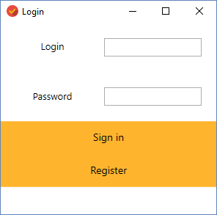

RegistrationWindow.xaml is a window, where registration process is held. The user needs to create his login, password, enter name, surname and date of birth so the registration can be completed.

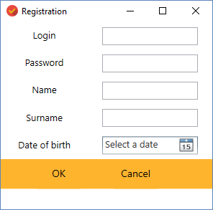

PlansWindow.xaml is a window, there user can manage his plans and tasks and manipulate them. It is possible to add, delete, edit and save plans, mark them as completed, watch the list of completed tasks and exit the application.

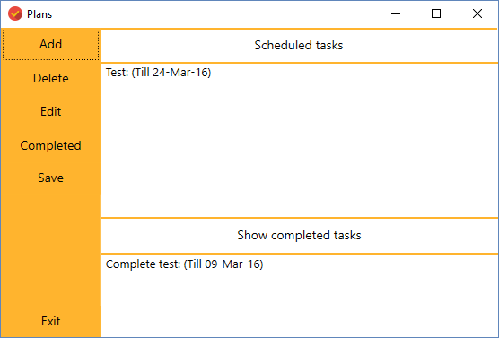

PlanDescription.xaml is a window where user enters the description of the plan he wants to add and a deadline. This window is also used when user needs to edit his plan.

